Below is a clear, in-depth, professional DAY 4 document on Test Execution & Defect Flow in Xray, written in simple language, with real-project scenarios and step-by-step hands-on for every topic.
You can directly submit this for lab records / training reports / internal assessment.

DAY 4 – TEST EXECUTION & DEFECT FLOW (XRAY)
1. Test Execution Lifecycle
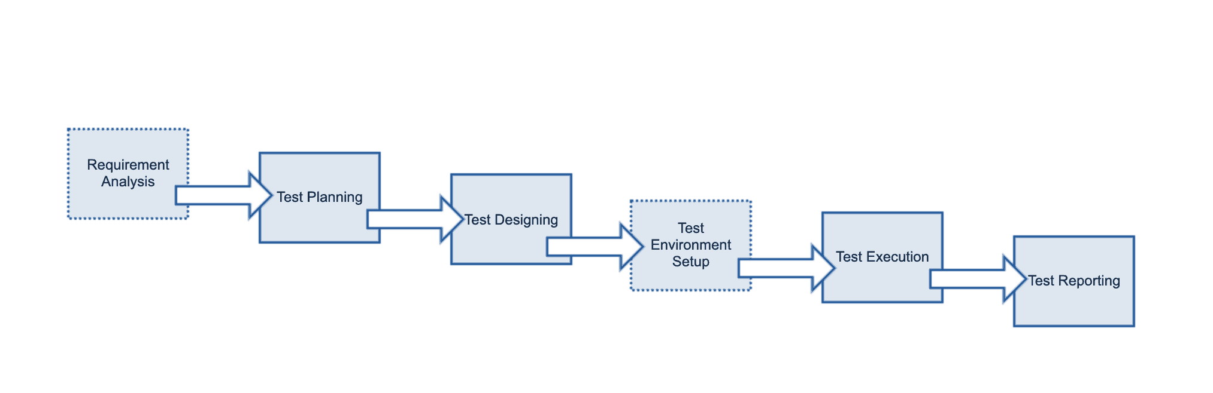
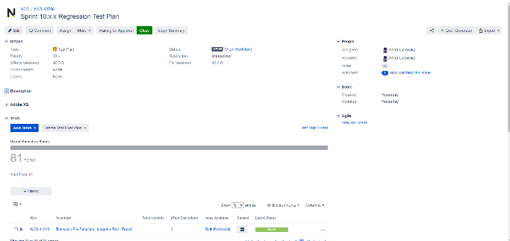

In Xray Test Management, a Test Execution represents a single run of tests for a build, sprint, or release.
1.1 Creating a Test Execution
A Test Execution answers: Which tests were run? When? By whom? With what result?
Steps:
- Click Create Issue
- Select Issue Type → Test Execution
- Enter summary (e.g., Sprint 3 – Login Module Execution)
- Save the issue

1.2 Adding Tests to Execution
There are two common ways:
A. Add Individual Tests
- Open Test Execution → Add Tests
- Search and select required Tests
B. Add Test Sets
- Link a Test Set to the Test Execution
- All tests inside the Test Set are added automatically
📌 Best Practice:
Use Test Sets for smoke/regression to save time and ensure consistency.

2. Executing Tests
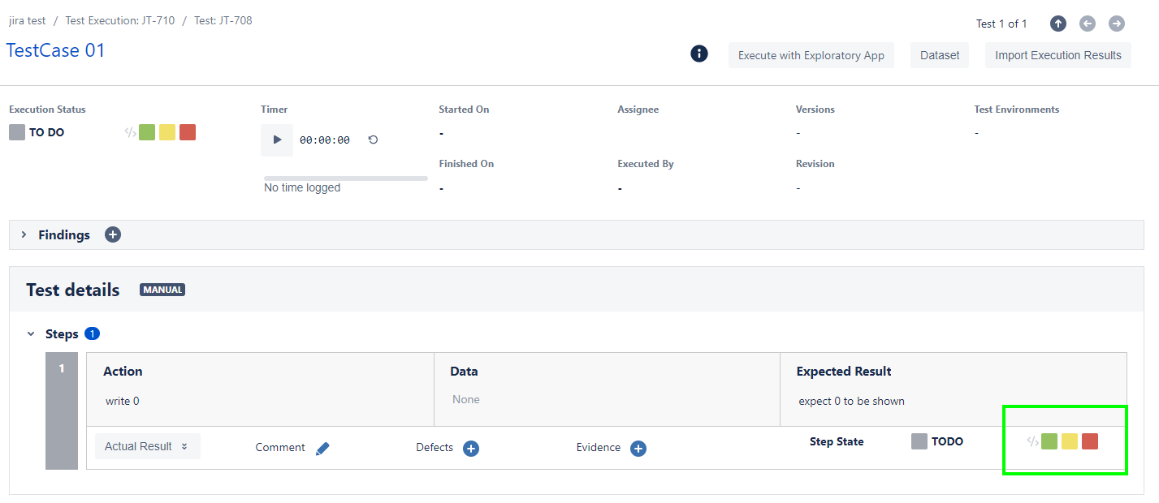
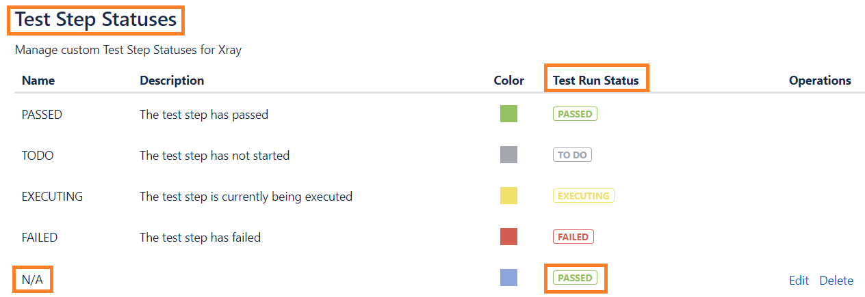
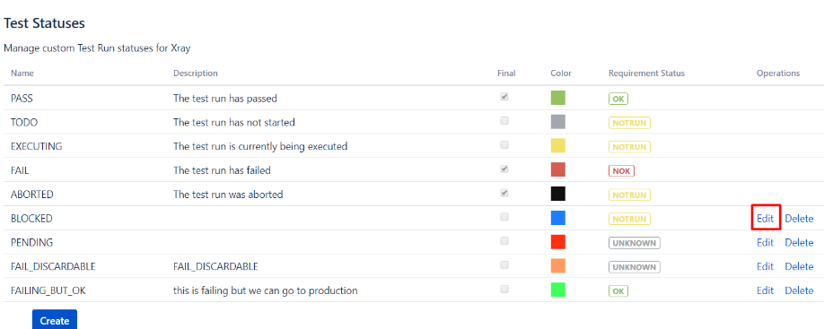
2.1 Execution Statuses
Status | Meaning | When to Use
Pass | Test behaves as expected | All steps successful
Fail | Test does not meet expected result | Functional defect
Blocked | Test cannot be executed | Dependency issue
Not Executed | Pending execution | Test not run yet

2.2 How to Execute a Test
- Open Test Execution
- Click on a Test
- Execute step by step
- Set status (Pass / Fail / Blocked)
- Save result

2.3 Execution Best Practices
- Execute tests in defined order
- Mark Blocked instead of Fail for environment issues
- Add clear comments for failures
- Do not guess results
📌 Real Project Tip:
Never mark a test as Fail without creating or linking a defect.

3. Evidence Management
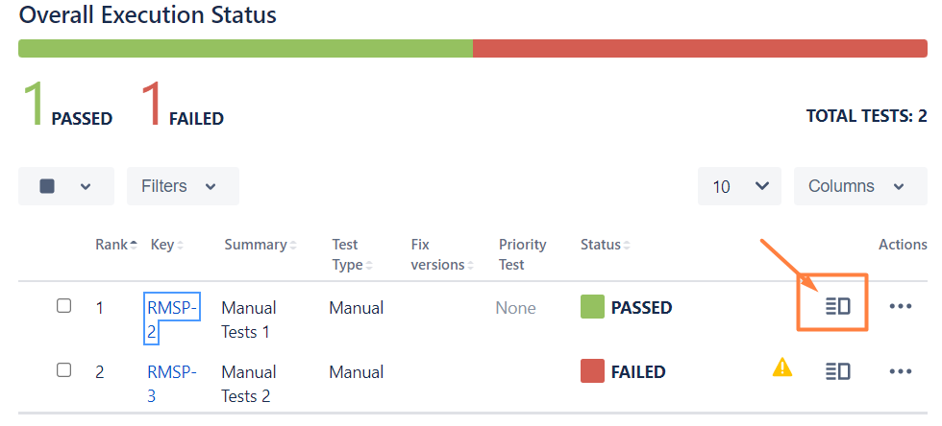
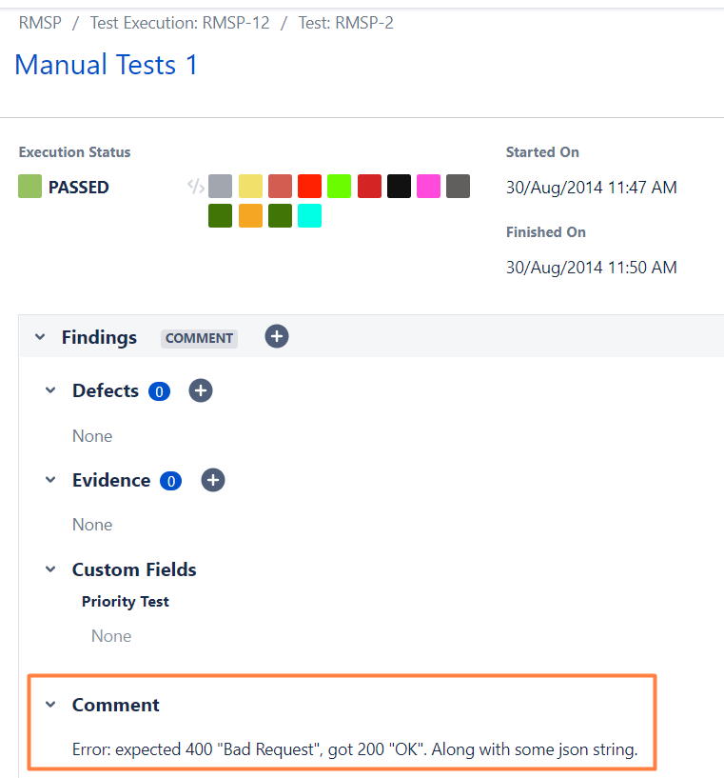
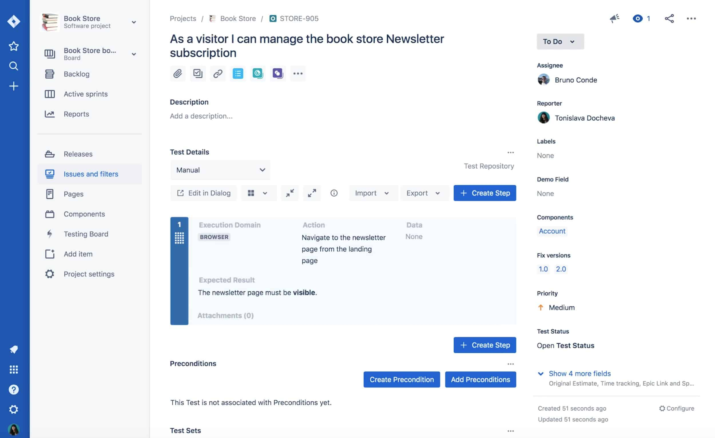
3.1 What is Evidence?
Evidence is proof of execution, such as:
- Screenshots
- Screen recordings
- Log files
- Error messages

3.2 How to Attach Evidence
- While executing a test, click Add Evidence
- Upload screenshot or file
- Add comments if required

3.3 Evidence Standards (Professional)
- File name should include test name or step
- Capture error message clearly
- Avoid unnecessary images
- One failure → one clear evidence
📌 Why Important?
- Helps developers debug faster
- Useful for audits and reviews
- Avoids execution disputes

4. Defect Flow
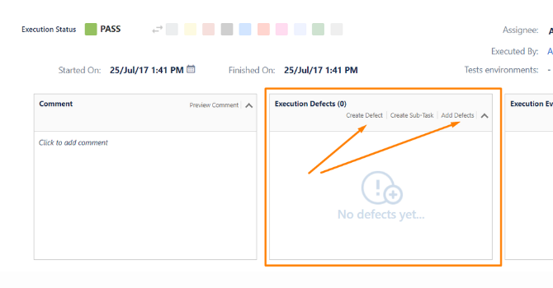
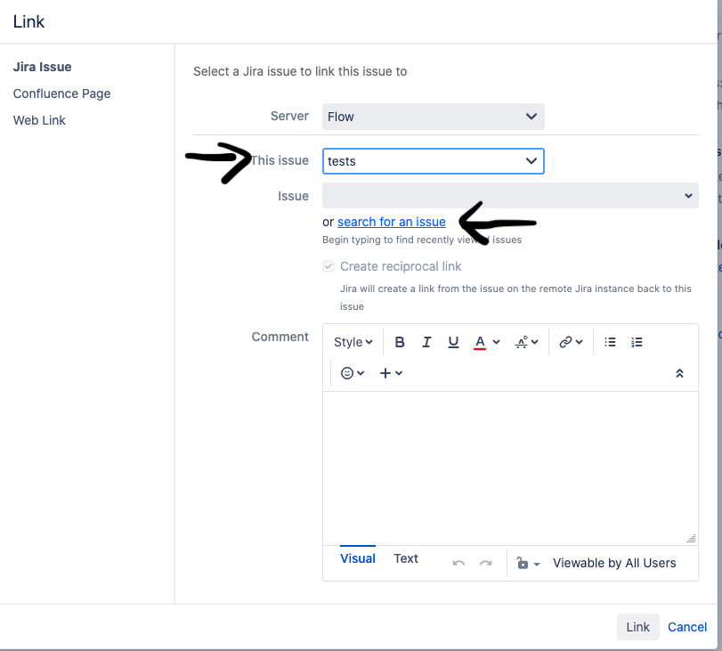

4.1 Creating a Defect from Failed Test
When a test fails, create a Bug immediately.
Steps:
- From failed Test Execution → Create Defect
- Issue Type → Bug
- Fill:
  - Summary
  - Steps to reproduce
  - Expected vs Actual result
- Save and link automatically

4.2 Linking Defects
A defect can be linked to:
- Test
- Test Execution
- User Story
📌 Best Practice:
Link defect to Test Execution, not only to Story.

4.3 Retesting After Fix
Once developer fixes the bug:
- Bug status → Ready for Retest
- Open same Test Execution or create new one
- Re-execute failed Test
- Update status:
  - Pass → if fixed
  - Fail → if issue persists

4.4 Execution History
Xray maintains:
- Previous execution results
- Who executed
- When executed
- Linked defects
📌 Enables trend analysis and quality tracking.

5. Hands-on Lab (Mandatory)
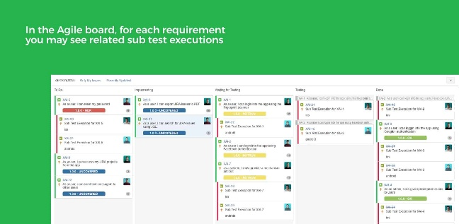

Hands-on Tasks
🔹 Task 1: Execute Tests
- Open a Test Execution
- Execute at least 3 Tests
- Mark:
  - 1 Pass
  - 1 Fail
  - 1 Blocked

🔹 Task 2: Attach Evidence
- Add screenshot for failed test
- Add comment explaining failure

🔹 Task 3: Create Defect
- Create Bug from failed test
- Link bug to Test Execution
- Verify defect visibility

🔹 Task 4: Retest
- Change bug status to Fixed
- Re-execute test
- Update final status

6. Summary
Day 4 covered the complete test execution lifecycle, including:
- Creating and managing Test Executions
- Executing tests professionally
- Managing evidence
- Handling defect creation, linking, and retesting
This day bridges testing and development, ensuring quality feedback loops and release confidence.

